Tracheostomy
Tracheotomy
- Surgical procedure in which an opening is made into the trachea

Tracheostomy Tube
- Indwelling tube inserted into the trachea
- Held in place by tape or straps fastened around the patient’s neck
- A square of sterile gauze is placed between the tube and the patients skin to absorb drainage, protect the patient’s skin, and prevent infection

Examples (More pictures on Pg. 738, Bruners)

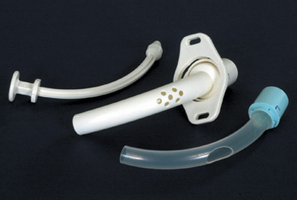
Tracheostomy
- Indications
  - To bypass an upper airway obstruction
  - To allow removal of tracheobronchial secretions
  - To permit long-term use of mechanical ventilation
  - To prevent aspiration of oral or gastric secretions in the unconscious or paralyzed patient
  - To replace an endotracheal tube

- Procedure
  - Usually performed in the operating room or in ICU
  - Surgical opening is between the 2nd and 3rd tracheal rings
  - A cuffed tracheostomy tube of appropriate size is inserted
  - The cuff is inflated to occlude the space between the walls and the tube, to permit effective mechanical ventilation and to minimize risk of aspiration

- Complications
- May occur early or late in tracheostomy management. May even occur years after the tracheostomy tube has been removed
- Early complications include: bleeding, pneumothorax, air embolism, aspiration, subcutaneous emphysema, recurrent laryngeal nerve damage, and posterior tracheal wall penetration
- Late complications include: airway obstruction from accumulation of secretions or protrusion of the cuff over the opening of the tube, infection, rupture of the innominate artery, dysphagia, tracheoesophageal fistula, tracheal dilation, and tracheal ischemia and necrosis
- Tracheal stenosis (narrowing) may develop after the tube is removed

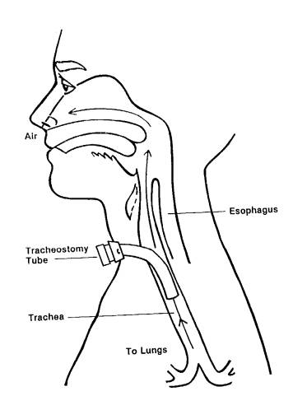

- Preventing Complications
- Maintain appropriate cuff pressure
- Suction as needed
- Maintain skin integrity
- Change tape and dressing as needed or per protocol
- Auscultate lung sounds routinely
- Monitor for signs/symptoms of infection (temp, WBC’s)
- Administer ordered O² and monitor oxygen saturation
- Monitor for cyanosis
- Maintain adequate hydration
- Use sterile technique when suctioning and performing trach care

- Nursing Management
- Continuous monitoring and assessment
- Keep the tracheostomy patent with proper suctioning of secretions
- Keep the patient in semi-fowler’s position to facilitate ventilation, promote drainage, minimize edema, and prevent strain on the sutures
- Administer analgesia and sedation with caution because they may suppress the coughing reflex
- Keep paper and pencil and the call bell within the patient’s reach at all times!

  - Suctioning
- Done when adventitious (abnormal) breath sounds are detected or whenever secretions are obviously present
- Unnecessary suctioning can cause bronchospasm or cause trauma to the tracheal mucosa
- All equipment coming in contact with the lower airway must be sterile
- See Chart 25-10 on Pg 741(Bruner) for Suctioning Procedure

See Chart 25-9 on Pg 740 (Bruner) for Tracheostomy Care Procedure

