Basic Respiratory A&P
Nares
- Filter out particles
- Humidify inspired air

Pharynx
- Passageway to digestive and respiratory tract
- Maintains air pressure in the middle ear
- Mucosal lining humidifies and warms inspired air and traps particles

Larynx
- Known as voice box
- Connects the upper and lower airways
- Contains vocal cords that produce sounds and initiate cough reflex

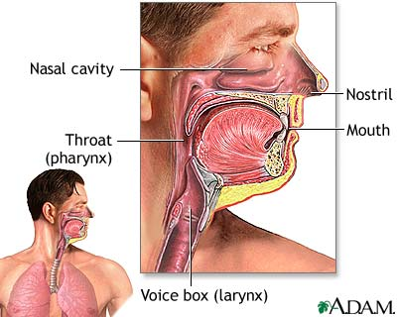

Trachea
- Consists of smooth muscle
- Contains C-shaped cartilaginous rings
- Connects larynx to the bronchi

Bronchi and bronchioles
- Formed from branching of the trachea
- Right main bronchus is larger and more vertical than the left
- Bronchioles branch into terminal bronchioles, which end in alveoli

Alveoli
- Cluster of “grape-like’ sacs enveloped by capillaries
- Site of gas exchange
- Coated with surfactant which reduces surface tension to keep alveoli from collapsing
- Diffusion of gases occurs across the alveolar-capillary membrane

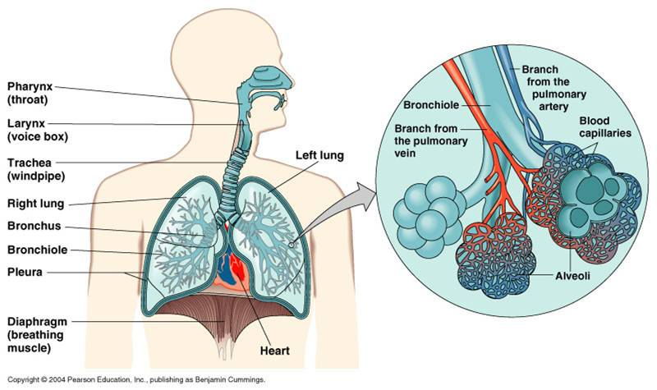

Lungs
- Composed of 3 lobes on the right side and 2 lobes on the left side
- Covered by pleura
- Regulate air exchange by concentration gradient

Pleura
- Visceral pleura covers the lungs
- Parietal pleura lines the thoracic cavity
- Pleural fluid lubricates the pleura to reduce friction during respiration

Tidal Volume (TV or VT)
- Volume of air inhaled and exhaled with each breath
- Normal value is 500ml or 5-10 ml/kg

Inspiratory Reserve Volume (IRV)
- Maximum volume of air that can be inhaled after a normal inhalation
- Normal value is 3000ml

Expiratory Reserve Volume (ERV)
- Maximum volume of air that can be exhaled forcibly after normal exhalation
- Normal value is 1100ml
- ERV is decreased with restrictive conditions such as obesity, ascites, or pregnancy

Residual Volume (RV)
- Volume of air remaining in the lungs after a maximum exhalation
- Normal value is 1200ml
- RV may be increased with obstructive disease

Vital Capacity (VC)
- Maximum volume of air exhaled from the point of maximum inspiration
- VC = TV + IRV + ERV
- A decreased VC may be found in neuromuscular disease, atelectasis, pulmonary edema, and COPD
- Normal value is 4600ml

Inspiratory Capacity (IC)
- Maximum volume of air inhaled after normal expiration
- IC = TV + IRV
- Normal value is 3500ml
- A decrease in IC may indicate restrictive disease

Functional Residual Capacity (FRC)
- Volume of air remaining in the lungs after normal expiration
- FRC = ERV + RV
- Normal is 2300ml
- May be increased with COPD or decreased with ARDS

Total Lung Capacity (TLC)
- Volume of air in the lungs after a maximum inspiration
- TLC = TV + IRV + ERV + RV
- May be decreased with restrictive disease (atelectasis, pneumonia) and increased with COPD

