Nervous System
Basic Anatomy & Physiology Review

Central Nervous System (CNS)
- Brain
- Spinal Cord
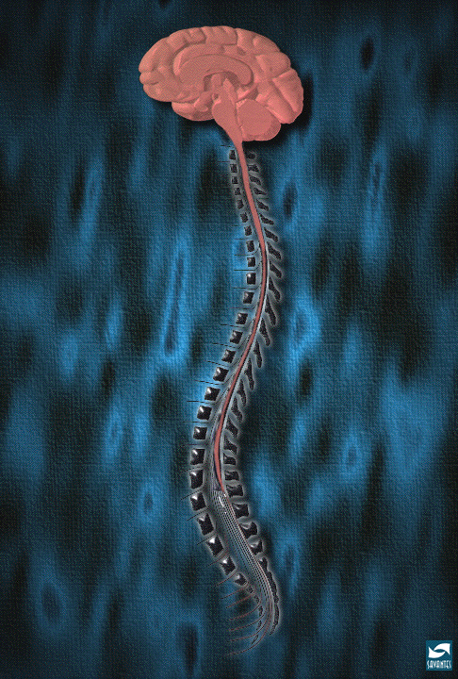

Peripheral Nervous System (PNS)
- Everything else
- Connects the CNS to the rest of the body
- Divided into:
  - Somatic Nervous System
    - Voluntary control of movements
    - Responsible for senses (hearing, touch, sight)

  - Autonomic Nervous System
- Control system of the body
- Maintains homeostasis
- Responsible for involuntary processes

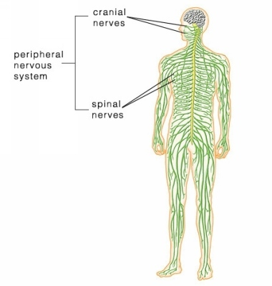
Neurons
- Process and transmit information
  - From the brain to the body and from the body to the brain
- Basic unit of the nervous system
Structure
- Soma- cell body that contains the nucleus
- Axon- tail that sends messages
- Myelin Sheath- waxy substance that covers and insulates the axon- the myelin sheath allows for faster transmission of impulses throughout the body. Without a myelin, impulses would be slower
- Dendrite- branches at the top of the cell body, receive incoming messages
- Axon Terminal- end of the tail responsible for releasing neurotransmitters and transmission of the message to the next neuron
- Synapse- tiny compartments at the axon terminal that release the neurotransmitters

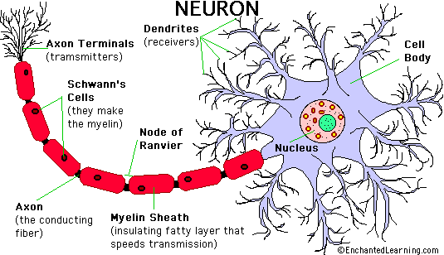
Types of Neurons

Motor Neurons
- Receive signals from the CNS
- Responsible for muscle contractions and glands (hormones)

Sensory Neurons
- Respond to the senses/sensory organs
- Send messages to the CNS

Inter-neurons
- Connect neurons to other neurons

Neurotransmitters
- Chemicals used to relay messages between neurons
- Lots of different neurotransmitters

A few important neurotransmitters

Acetylcholine (ACh)
- Works in the CNS and PNS
- In the CNS:
  - It plays a role in the cholinergic system (excitability)
  - Inhibits cardiac muscle contraction (parasympathetic response-slowing things down after a sympathetic or “fight or flight” moment)

- In the PNS
  - Activates skeletal muscle contraction
  - Major neurotransmitter

Norepinephrine
- Catecholamine (amino acid)
- Works as a neurotransmitter and a hormone
- Released in times of stress (sympathetic response)
- Increases heart rate, triggers glucose release, and increases blood flow to skeletal muscles (fight or flight!!!)

Dopamine
- Catecholamine (amino acid)
- Works as a neurotransmitter and a hormone
- Increases heart rate and blood pressure (sympathetic response)
- DOES NOT cross the blood brain barrier so it cannot get to the brain (this is very important for Parkinson’s Disease, because they are deficient in dopamine and must take Levodopa. Levodopa can cross the BBB, and when it does, its converted into dopamine

GABA
- Amino acid
- Inhibiting quality
- Drugs can be given to enhance the function of GABA which will result in sedative and tranquilizing effects

Serotonin
- Important in sleep cycles, anger, aggression, body temperature, sexuality, metabolism, and stimulation of vomiting

