Adult Client with Neurologic Alterations
Slide Addendum

Slide 3

- Central Nervous System = Brain & spinal cord
- Peripheral Nervous System = Everything BUT the brain and spinal cord
- Autonomic Nervous System
  - Sympathetic
- Fight or flight
- Neurotransmitters involved are epinephrine and norepinephrine
  - Parasympathetic
- Regulation/Maintains homeostasis
- Neurotransmitter is acetylcholine

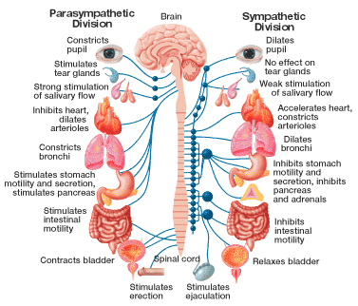

Slide 4

Parts of the Brain

Cerebrum

Hemisphere
- The brain is divided into two hemispheres, right and left
- Each hemisphere contains 4 areas (frontal, temporal, parietal, and occipital)

Gray Matter
- What we see when we look at the brain
- Bunch of closely packed neuron cell bodies
- Includes areas of the brain that control muscles, sensory perceptions, such as seeing and hearing, memory, emotions, and speech

White Matter
- Situated between the brain stem and the cerebellum
- Consists of long, myelinated axons
- Consists of structures in the core of the brain including the hypothalamus and the thalamus
- This area regulates autonomic functions that are involuntary including heart rate, respirations, temperature, and blood pressure
- Other functions of the white matter include the release of hormones from the pituitary gland and regulation of food and water intake

Cerebellum
- Responsible for psychomotor function
- Coordinates sensory input from the inner ear and the muscles to provide control of position and movement (balance)

Brainstem
- Located at the base of the brain
- Forms the link between the cerebral cortex, white matter, and the spinal cord
- Controls breathing, sleeping, and heart rate

Basal Ganglia
- Consists of caudate nucleus, putamen and globus pallidus
- Involved in movement control
- Found in the white matter, beneath the cerebral cortex

Thalamus
- Connects to the basal ganglia, hypothalamus, and brain stem
- Processes and relays sensory input to the cerebral cortex
- Regulates states of sleeping and wakefulness
- Regulates arousal, level of consciousness
- Damage to the thalamus can result in permanent coma

Hypothalamus
- Links the nervous system to the endocrine system via the pituitary gland
- Located below the thalamus
- Synthesizes and secretes neurohormones
- Controls body temperature, hunger, thirst, fatigue, anger, and circadian cycles

Ventricles
- Hollow cavities within the brain (4 ventricles in the human brain)
- Site of CSF production

Slide 6
- Protective structures of the brain

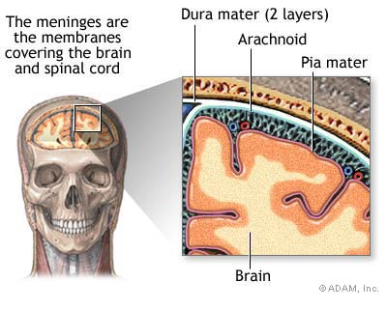
CSF
- Clear, colorless
- Produced by the choroid plexus in the ventricles and arachnoid layer
- We produce about 500ml per day
- Most CSF is absorbed by the body

Slide 7
- The amount of glucose and oxygen delivered to the brain is regulated by blood flow to the brain

Slide 8
- PET scans measure “hot spots” or areas with high glucose concentrations in the brain
- EEG’s measure the electrical activity of the brain by looking at brain waves
- EMG measures electrical activity of the muscle and the brain activity sent to muscle

Slide 9
- Pt must be very still during and after procedure
- A needle is typically inserted into the femoral artery, similar to a cardiac cath, or into the upper arm
- Important to educate the patient on what to expect (flushed, warmth, burning, metallic taste, immobility requirements) so that they don’t become anxious because of it

Slide 10
- Bedrest is required so that the insertion site develops a clot, and bleeding stops
- Assess peripheral pulses to assess circulation
- Make sure to keep the bed flat if the femoral artery is used
Slide 11
- LP and myelography are contraindicated with increases ICP because they may cause herniation, meaning the brain stem is sucked down into the spinal cord
Slide 12
- For an LP, the patient must remain flat after the procedure
- Keep the HOB up for 3 hrs after myelography to move the dye down and out of the body
- Drink plenty of fluids to replace CSF

Slide 13
- Headache is from the shift of CSF fluid in the head
- Do not perform either procedure for patients with:

1. Bleeding precautions
2. Heparin drips
3. Lovenox, Coumadin, ASA therapy

Slide 14
- Make sure to ask the patient open-ended questions
- Don’t put ideas into their heads

Slide 17

Raccoon’s Eye

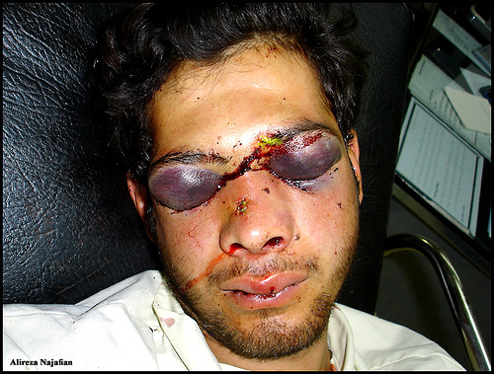

Battle’s Sign

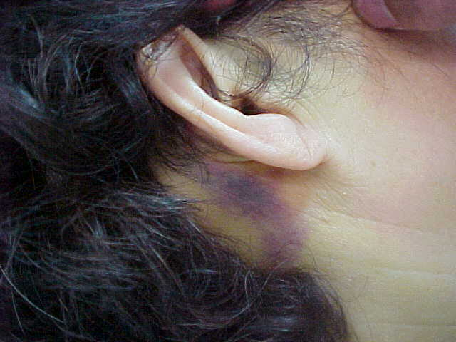

- Rhinorrhea and Otorrhea associated with head trauma may be a CSF leak
- If it is truly CSF, it will contain glucose (Perform Accu-check on the fluid)

Slide 18
- Applies to comatose patients
- When eyes move opposite of the way the head is turned
- Sign of severe brain stem injury
- Sometimes a sign of brain death
- ALWAYS make sure the cervical spine has been cleared before attempting

Slide 20

Bad | Decorticate Posturing | Cerebellar Function | Internal rotation “Towards the core”
Worse | Decerebrate Posturing | Cerebellar Function | Flexion “Away from the core”
Worst | Flaccid Posturing | Cerebellar Function | No motor tone or function, just limp

Slide 21
- ALTERED LEVEL OF CONSCIOUSNESS IS THE 1ST SIGN OF A CEREBRAL PROBLEM!!
- Altered LOC can be anything from agitation to coma

Slide 24

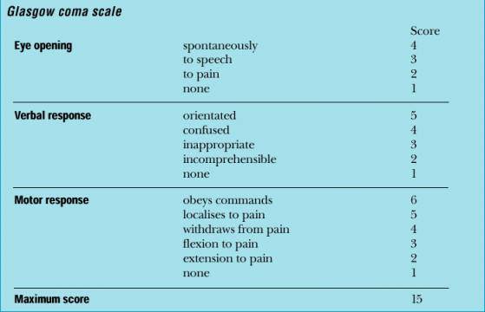

Slide 29
- A flat EEG can be interpreted the same as a flat ECG (death)
- When pupils are fixed and dilated, they are often referred to as “blown”

Slide 32
- The blood brain barrier (BBB) is the brain’s defense mechanism
- Chemo does not cross the BBB so IV chemo does not work for primary brain ca

Slide 42
- Cushing’s triad is
  - Widening Pulse Pressure (ex. 190/40)
  - Bradycardia
  - Bradypnea or irregular respirations

- Indicative of increased intracranial pressure secondary to cerebral hemorrhage or brain tumor
- May be a sign of impending brain herniation which is fatal if not treated immediately

Slide 48
- Understand that diabetes insipidus and SIADH can occur as complications of increased intracranial pressure
- Beyond that, don’t need to know about what they are

