Nursing Management of the Adult Client with Neurologic Alterations
Neoplasms and Infections
Slide Addendums

Slide 2
- Astrocytomas spread by infiltration like ivy vines
- Death is highly likely with astrocytomas

Slide 3
- Neuromas a small, slow growing tumors on a nerve
- An acoustic neuroma is the most common kind
- This is a tumor sitting on the acoustic nerve
- Patients with acoustic neuromas lose hearing in that ear
- These are usually benign
- Pressure from Pituitary Adenomas cause patients to develop diabetes insipidus
- Angiomas are a result of AV malformation (AVM) and increase the risk of hemorrhagic CVAs

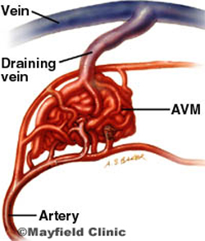

Slide 4
- Brain tumors are usually unknown until they become symptomatic
- Localized manifestations depend on the location and type of tumor
- Seizures are related to abnormal electrical activity secondary to the tumor
- Mental status changes may be the 1st sign you notice
- In the elderly population, mental changes may be ignored or seen as part of the normal aging process

Slide 5 & 6 (see brain tumor manifestation doc)

Slide 9

- Surgical intervention may be done for support (palliation) or curative measures
- Give corticosteroids to reduce inflammation

Slide 10
- Brain cancer can be primary or metastatic
- It is the job of the entire healthcare team to make sure the patient is aware and understands the long-term prognosis

Slide 11
- Risk for aspiration comes into play because the patient may lose the ability to swallow and/or the gag reflex related to increased ICP
- Seizure precautions involve hourly safety checks, side rails up, padding around the patient, nothing hard near the patient, floor is free of obstacles

Slide 12
- Cachexia = wasting

Slide 15
- Burr hole = tiny hole in the cranium (tiny sunroof if that helps ☺ )
- Craniotomy = creation of a hole in the cranium
- Craniectomy = removal of a piece of the cranium
- Cranioplasty = putting the removed piece back

Burr Hole

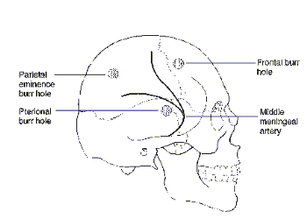

Craniotomy

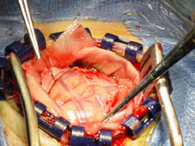

Craniectomy

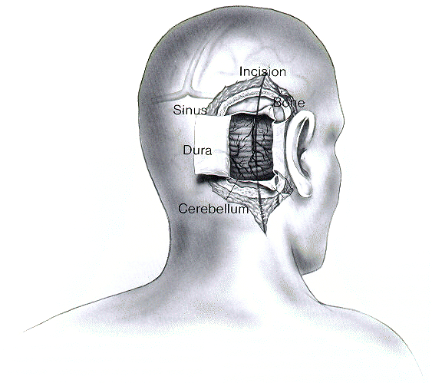

Cranioplasty (can be synthetic or bone)

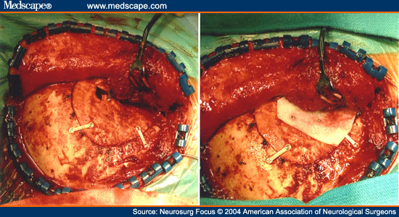

Slide 18
- In a patient with a craniotomy, disturbed body image may result
- The patient cannot wear wigs in the immediate post-operative period

Slide 19
- Spinal cord tumors can be anywhere
- 50% are in the T-spine
- 30% are in the C-spine
- 20% are in the L-spine
- Only 0.5-1% of all tumors are spinal cord tumors (very rare)

Slide 20
- There will be a progressive loss of motor function and paralysis below the tumor

Slide 21
- Debulking is taking out as much of a tumor as possible to relieve pressure and some symptoms. This is a form of palliative care
- High-dose Decadron should be given within 8 hours of spinal cord injury or A.S.A.P for spinal cord tumors to relieve swelling
- Immediate relief of edema can decrease damage and symptoms

Slide 22
- Meningitis is an inflammation of the meninges
- Bacterial meningitis is the most severe form
- Meningitis can also be fungal or parasitic
- High-risk groups for meningitis include people living in close quarters, patients with head trauma, and patients with severe, recurrent otitis media (middle ear infections)

Slide 26
- Vaccines are only available for bacterial meningitis
- Elderly may present with different symptoms, especially afebrile
- Can only treat symptoms for viral meningitis ( no antibiotics)

Slide 30
- Viral meningitis may be caused by
  - Herpes Zoster
  - Herpes Simplex
  - Cytomegalovirus (CMV)

