Medications

Mannitol

Class: Osmotic Diuretic
Action: Pulls water and electrolytes out of the tissue and into the vasculature to be excreted by the kidneys
Goal: Reduce ICP
SE: Dehydration, electrolyte imbalance (Na & K), temporary volume expansion
Contraindications: Renal Failure

Things to think about…

Mannitol is going to pull water & electrolytes from the tissues into the vessels for excretion. When you do this, it will temporarily increase the blood pressure because we are adding more “fluid” in the vessels. This is a potent diuretic so the kidneys are going to work pretty quickly to excrete this extra fluid. Check the urine output at least hourly to be sure the kidneys are doing their job. In addition, the vital signs will return to normal as the kidneys excrete the excess fluid that Mannitol pulled out of the tissues

So if we gave this to a renal failure patient, the mannitol would still pull the fluid out of the tissues. It would still pull the fluid into the vessels. The problem is all that extra fluid has nowhere to go… The kidneys can’t get rid of the excess fluid. The kidneys need to work to achieve the goal of decreased intracranial pressure.

Mannitol is a vesicant, meaning it’s really hard on the veins. In fact, it develops crystals in the vial. When you give Mannitol, you have to draw it up through a filter needle to prevent pulling crystals into the syringe. When you give it, you must use a new filter needle to prevent crystals from reaching the patient.

Remember
- Assess your patient
- Review previous medical history
- Assess baseline vitals before administration
- Monitor vitals frequently during Mannitol Therapy
(expect a temporary increase in BP)
- Monitor output every hour (use a foley with a urometer)
(look for at least 100cc every hour)
- Frequently assess your patient
- Monitor lab values (especially electrolytes)

Urometer 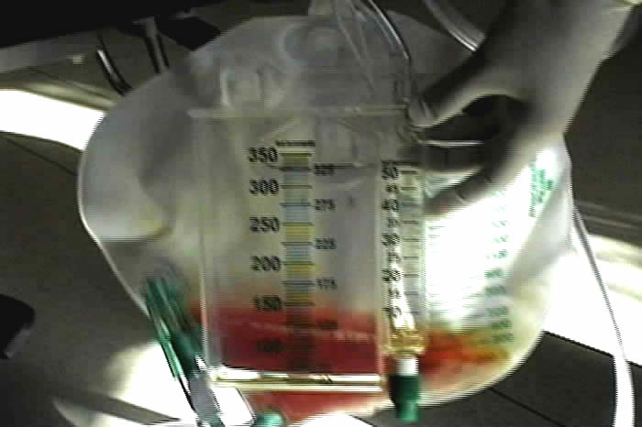

Propofol

Class: Anesthetic
Goal: Rapid sedation for critically ill patients, reduction of stress on the body
SE: Hypotension, bradycardia, decreased cardiac output, apnea
Contraindications: None

Things to think about...

- Propofol should only be administered by staff that are trained in the administration of anesthetics
- Resuscitation equipment must be in the immediate area
- These patients require some means of ventilation
- Propofol works by rapid sedation
- The effects of propofol wear off quickly (15 minutes)

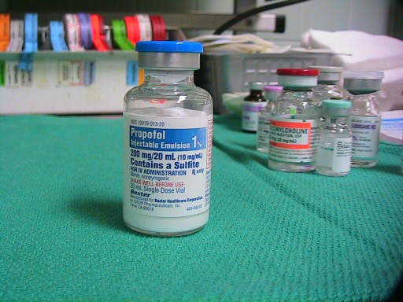

Nimotop

Class: Calcium Channel Blocker
Indication: Sub-arachnoid hemorrhage and intracerebral hemorrhage
Action: Inhibits calcium from moving into the cell with sodium prohibiting smooth muscle contraction
Goal: Prevent vasoconstriction, vasospasm which prevents cerebral ischemia and its effects
SE: Hypotension, bradycardia, flushing of the skin, headache, and nausea
Other : This medication cannot be given IV. It comes in pill form only. The only variation to PO form is that the liquid in the capsule can be drawn out and given via Dobhoff or NG tube

Apresoline

Class: Direct vasodilator; anti-hypertensive
Indication: Autonomic dysreflexia, primary hypertension
Action: Causes arteriolar vasodilation by relaxing smooth muscle
Goal: Reduction in blood pressure and arterial vasodilation
SE: Hypotension, edema, dyspnea,

Nursing Implications
- Monitor pulse and blood pressure every 15 minutes after administration until vitals are stable
- Monitor I & O
- Explain to the patient that they may experience a headache from the med
- Observe for changes in level of consciousness
- Teach client about orthostatic changes
- Instruct the client to immediately report difficulty breathing, dizziness, or weakness

Dantrium

Class: Anti-spastic muscle relaxant
Indication: Chronic neurological disorders causing spasms such as spinal cord injuries, stroke, MS
Action: Relaxation of the contractile response directly on the muscle itself
SE: Drowsiness, weakness, tachycardia, sweating
Contraindications: Avoid alcohol and CNS depressants

Baclofen

Class: Anti-spastic muscle relaxant
Indication: Chronic neurological disorders causing spasms such as spinal cord injuries, stroke, MS
Action: Inhibits reflexes at the spinal level
SE: Drowsiness, dizziness, nausea, hypotension
Contraindications: Avoid alcohol and CNS depressants

