Nursing Management of the Adult Client with Neurologic Alterations
Head and Spinal Cord Injury
Slide Addendums
Part 2

Slide 40
- 12-14 thousand new spinal cord injuries, every year
- 16-30 year olds make up about 50% of these cases
- Increased risk factors include:
  - Age (16-30)
  - Gender (male)
  - Alcohol or drug abuse

- Most of these injuries occur in motor vehicle collisions and diving accidents
- Most common injuries are:
  - C5, C6, C7
  - T12 and L1

- These vertebra are the weakest because they are in the curvature of the spine, and because they have the greatest range of mobility
- Spinal cords do not regenerate
- Severing or “transecting” the spinal cord results in an immediate loss of sensory and motor function
- These losses CANNOT be fixed
- The loss of motor and sensory function occurs from the point of transection down the rest of the body

Slide 42
- There is a lot of variation in the types of spinal cord injury
- Will take some time to fully understand the depth of injury

Slide 46
- Don’t memorize the actual grading system
- Just understand that there is a scale to evaluate a spinal cord injury

Slide 52
- Spinal cord injury traction is short term, usually only until surgical intervention
- There will be an order for the amount of weight to be used
- Pin care depends on the doctor, make sure to keep skin clean

Tongs
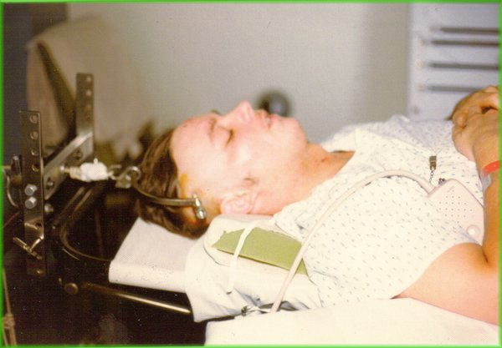

Slide 53
- Don’t ever pull on the halo bars!

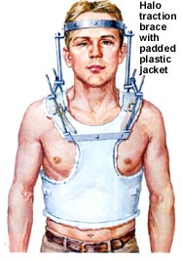

Slide 54
- Also make sure to assess temperature

Slide 57
- Spasticity of the muscles develops secondary to the spinal cord injury
- Use trochanter rolls to keep legs from rolling off the bed

Slide 58
- Orthostatic hypotension is common in the first two weeks after the injury
- The vasculature below the spinal cord injury becomes flaccid meaning the vessels can’t adjust quickly like normal vessels, making them more prone to orthostatic changes.
- These patients need to be on a tilt table to get them used to changes in position

Slide 59
- Spinal cord injury patients are at risk for autonomic dysreflexia for the rest of their life
- This is an emergency condition in response to NORMAL stimuli
- Most commonly, it’s a full bladder or constipation

Slide 60
- Autonomic dysreflexia is an EMERGENCY!
- Figure out the cause and fix it immediately

Slide 62
  - Assess the patient
  - Raise the head
  - Fix the cause
  - Give Apresoline if the problem isn’t fixed within 15 minutes

- After the first time it happens, the patients are more prone to have it again

Slide 63
- Spinal shock happens immediately after injury
- It’s due to the immediate loss of all motor and sensory function below the transaction
- Intestinal decompression (NG tube) does not prevent or fix shock, but it prevents an ileus

Slide 64
- Neurogenic shock is the next step after spinal shock
- This can last for months

Slide 67
- Get the patient as independent as possible

