Nursing Management of the Adult Client with Neurologic Alterations
Head and Spinal Cord Injury
Slide Addendums
Part I

Slide 2

- The skull has a fixed capacity… No room to grow!
- It cannot swell to accommodate for increased pressure
- Because of this, minor head injuries can be a major problem
- The most common cause of death from trauma is a head injury
- The most severe is closed, blunt-force head trauma
- A closed head injury is the most severe because it doesn’t allow room for swelling
- With an open head wound, there is at least room to grow

Slide 3
- Primary injury = Head hits a windshield
- Secondary injury = A slow bleed that wasn’t picked up or develops after the initial injury

Slide 4
- This is the story of a head injury

Slide 5
- The scalp is full of tiny blood vessels that bleed heavily with injury
- A scalp avulsion is a true emergency

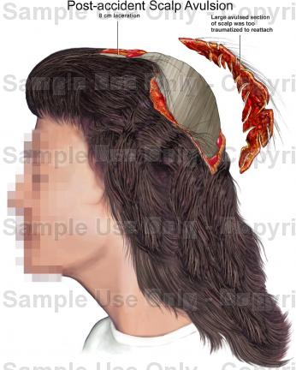

Slide 6

Coup-Contrecoup Injury
- Brain comes in contact with a fixed object
- It bounces from front to back or side to side, injuring two parts of the brain

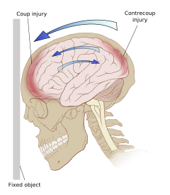

Basilar Skull Fracture
- Will injure cranial nerve (CN) I, II, VII, VIII

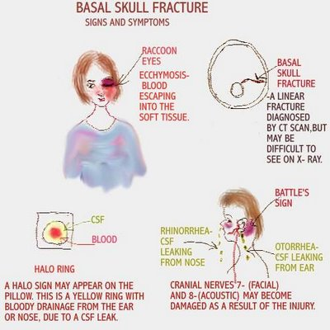
Slide 8
- Avoid nose blowing, sneezing with a closed mouth, and coughing because it increases ICP

Slide 9
- Neurologic changes may include agitation, restlessness, or lethary
- Teach the family what to look for!

Slide 12
- The effects of a brain injury may last for months

Concussion
- TEMPORARY loss of function
- May lose consciousness for only a few minutes
- No apparent structural damage
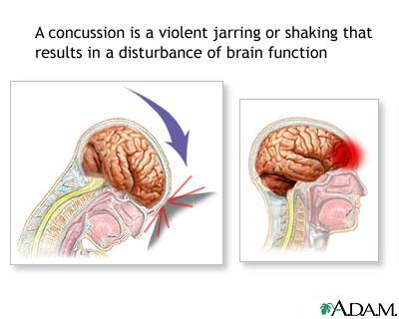

Contusion
- Unconscious for greater than a few minutes
- May cause a surface hemorrhage

Slide 16

Intracranial Hemorrhage
- Can be the result of blunt or penetrating head trauma
- Can also be the result of leukemia and thrombocytopenia
- 4 Types
  - Epidural Hematoma
  - Subdural Hematoma
  - Intracerebral Hematoma
  - Intracerebral Hemorrhage

Epidural vs. Subdural

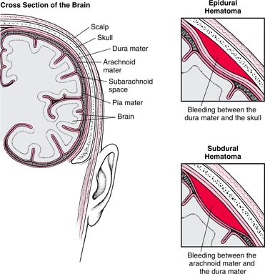

Slide 17
- An epidural hematoma is an arterial bleed
- Ipsilateral (same side) dilation and fixation of the pupil
- Contralateral (opposite side) paralysis of extremity
- Symptoms differ based on where the bleed is located

Slide 19
- The burr holes increase the risk of infection and bleeding
- A burr hole is like a tiny sunroof in the skull

Slide 20
- An subdural hematoma involves venous bleeding
- It is not as dramatic as an epidural bleed

Slide 23
- Elderly patients may not even remember that they fell

Slide 25
- Anticoagulant therapy includes Plavix

This is a huge intracerebral bleed on CT scan (looks like a white ball)
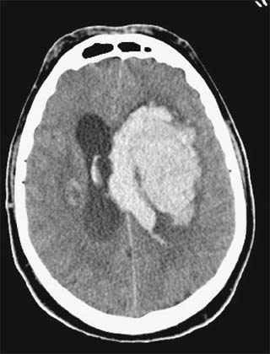

Slide 28
- Make sure to turn off NG suction before listening to bowel sounds
- If a patient has an ileus, bowel sounds will be hyperactive above the ileus and hypoactive or absent below it

Slide 35
- Avoid valsalva maneuvers by administering stool softeners

