SINUS BRADYCARDIA

Definition
- Sinus impulse slower than normal (Less than 60 BPM)

Causes

Metabolic
- Sleep
- Athlete
- Hypothyroidism

Vagal Response
- Vomiting
- Defecation
- Severe Pain
- Extreme emotions

Medications
- Calcium Channel Blockers
- Amiodarone
- Beta-Blockers

Other
- Hypovolemia
- Increased ICP
- MI (especially inferior wall)
- Hypoxia
- Acidosis
- Hypo or Hyperkalemia
- Hypoglycemia
- Hypothermia
- Toxins
- Cardiac Tamponade
- Tension Pneumothorax
- Coronary or Pulmonary Thrombosis

Characteristics

Ventricular & Atrial Rate: Less than 60 BPM (adult)
Ventricular & Atrial Rhythm: Regular
QRS Shape & Duration: Usually normal. QRS < 0.12 seconds
P Wave: Normal and consistent shape, always in front of QRS complex
PR Interval: Consistent interval between 0.12 and 0.20 seconds
P:QRS Ratio: 1:1

Other
- The only difference in Sinus bradycardia and a normal sinus rhythm is the rate (less than 60bpm)
- Assess the patient to determine the cause
- Prevent further vagal stimulation
- Withhold medication if it is the cause

Treatment
- If the bradycardia is causing hemodynamic changes resulting in dyspnea, altered mental status, angina, hypotension, ST-segment changes, or premature ventricular complexes, treat by increasing the heart rate
- Drug of choice is Atropine (0.5mg, rapid IV push) every 3-5 minutes (max. 3mg)
- Atropine blocks vagal stimulation
- Rarely, catecholamines and emergency transcutaneous pacing may be implemented

Sinus Bradycardia

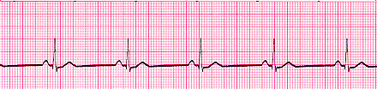
SINUS TACHYCARDIA

Definition
- Sinus impulse faster than normal (greater than 100 BPM)

Causes

Physiologic or Psychologic Stress
- Acute blood loss
- Anemia
- Shock
- Hypervolemia
- Hypovolemia
- Heart failure
- Pain

Hypermetabolic States
- Fever
- Exercise
- Anxiety

Medications
- Medications that stimulate the sympathetic nervous system response (catecholamines, aminophylline, & atropine)
- Stimulants (caffeine, alcohol, nicotine)
- Illicit drugs (cocaine, amphetamines, ecstacy)

Cardiac Function
- Enhanced automaticity of the SA node
- Postural Orthostatic Tachycardia (POTS) or tachycardia without hypotension within 5-10 minutes of standing up

Characteristics

Ventricular & Atrial Rate: Greater than 100 BPM and usually less than 120 BPM (adult)
Ventricular & Atrial Rhythm: Regular
QRS Shape & Duration: Usually normal. QRS < 0.12 seconds
P Wave: Normal and consistent shape, always in front of QRS complex, may be buried in T wave
PR Interval: Consistent interval between 0.12 and 0.20 seconds
P:QRS Ratio: 1:1

Other
- The only difference in Sinus tachycardia and a normal sinus rhythm is the rate (greater than 100 BPM)
- As the heart rate increases, the diastolic filling time decreases, possibly resulting in reduced cardiac output
- May be symptomatic with syncope and low blood pressure
- If the rapid rate persists, and the heart cannot compensate for the decreased ventricular filling, acute pulmonary edema may occur

Treatment
- Determined by the severity of symptoms
- Patient may be asked to bear down (vagal response)
- Calcium channel blockers and beta blockers may be utilized
- Catheter ablation of the SA node
- Treatment of POTS may include increased fluid and sodium intake, and the use of compression stockings to prevent blood pooling in the lower extremities

Sinus Tachycardia

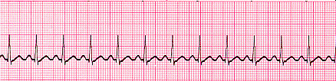

ATRIAL FLUTTER

Definition
- Flutter occurring in the atria creating impulses at a regular atrial rate between 250 and 400 times per minute
- Because the atrial rate is faster than the AV node can conduct, not all atrial impulses are conducted into the ventricle, causing a therapeutic block at the AV node

Causes

- Rheumatic heart disease
- CHF
- AV valve disease
- Post-cardiac surgery

Characteristics

Ventricular & Atrial Rate: Atrial rate 250-300; ventricular rate ranges between 75-150
Ventricular & Atrial Rhythm: Atrial rhythm is regular, ventricular rhythm is usually regular, but may be irregular because of a change in AV conduction
QRS Shape & Duration: Usually normal. QRS < 0.12 seconds (may be abnormal or absent)
P Wave: Sawtooth P wave
PR Interval: Absent
P:QRS Ratio: 2:1, 3:1, or 4:1

Treatment
- Oxygen
- Medications: Amiodarone, Cardizem, verapamil is rare

Atrial Flutter

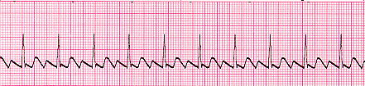

ATRIAL FIBRILLATION

Definition
- A rapid, disorganized, and uncoordinated twitching of the atrial musculature

Causes
- Increased Age
- MI
- Heart Failure
- Cardiomyopathy

Characteristics

Ventricular & Atrial Rate: Atrial rate >350; Ventricular <100
Ventricular & Atrial Rhythm: Highly irregular
QRS Shape & Duration: Usually normal. QRS < 0.12 seconds (may be abnormal)
P Wave: Absent, fibrillatory waves only
PR Interval: Absent
P:QRS Ratio: Many:1

Other
- Most common dysrhythmia in US
- No atrial contraction, just fibrillation
- Can lead to a clot in the atria
- Commonly seen after cardiac surgery
- Can be chronic or intermittent

Symptoms
- Dyspnea
- Fatigue
- Weakness
- JVD
- Anxiety
- Syncope
- Palpitations
- Chest discomfort
- Irregular Pulse

Interventions
- If <48 hours, treatment is aimed to decrease ventricular response and conversion back to a normal sinus rhythm
- If >48 hours, no cardioversion, because it may cause a pulmonary embolus
- Coumadin therapy

Atrial Fibrillation

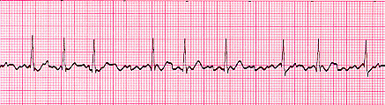

Premature Ventricular Contractions (PVC)

Definition
- A ventricular impulse contracts out of sequence due to an irritated electrical cell
- This may occur due to one or more cells
- One cell PVC’s are referred to as UNIFOCAL
- PVC’s originating from more than one cell are called MULTIFOCAL

Causes
- Age
- MI
- Heart Failure
- Caffeine
- Hypokalemia
- Can be random & without cause

Characteristics

Ventricular & Atrial Rate: Depends on underlying rhythm
Ventricular & Atrial Rhythm: Irregular due to early QRS, creating one RtoR interval that is shorter than the rest
QRS Shape & Duration: Duration is 0.12 or longer; shape is bizarre and abnormal
P Wave: Visibility depends on timing of the PVC; may be absent (hidden in the QRS or T wave)
PR Interval: <0.12 seconds
P:QRS Ratio: 0:1 or 1:1

Symptoms
- Can be symptomatic or not
- Palpitations
- Chest pain (from lack of perfusion)
- Hypotension
- Can be a warning before onset of v-tach, v-fib, or RonT phenomenon (AMI)
- There is NO P wave with a PVC

Treatment (If symptomatic)
- Identify & eliminate cause
- Oxygen
- Lidocaine
- MONA (morphine, oxygen, Nitro, ASA)

Unifocal PVC’s (PVC’s look alike; same origin)

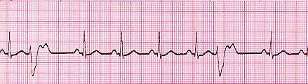

Multifocal PVC’s (PVC’s appear different; different origin)

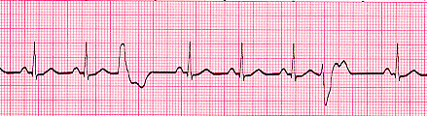

REFRACTORY PERIOD

- Onset of QRS complex to the peak of the T wave
- Cardiac cells cannot be stimulated to conduct an electrical impulse, no matter how strong the stimulus

RELATIVE REFRACTORY PERIOD

- Corresponds with the down slope of the T wave
- Cardiac cells can be stimulated to depolarize if the stimulus is strong enough

A very funny, but accurate analogy about refractory periods from http://www.drsegal.com/medstud/ecg/Electric.htm

Imagine, if you will, a toilet. Please bear with me... I swear this will work!
When you pull the handle, (initiate an impulse) water floods the bowl(kinda' like contraction!). This event takes a couple of seconds and you cannot stop it in the middle. Once the bowl empties, the flush is complete. Now the upper tank is empty. If you try pulling the handle at this point, nothing happens (absolute refractory?) Wait for the upper tank to begin refilling (Potassium moves back). You can now flush again, but the intensity of the flushes increases as the upper tank refills (relative refractory...)
Physiology will never be the same again...

R on T PHENOMENON

- Appearance of a PVC on T wave of preceding normal beat
- Can lead to Ventricular Fibrillation
- May see with an MI
- May convert into v-tach,v-fib
- Never a good thing!

R on T Phenomenon (notice the pt starts with an elevated ST segment, then R on T (where it says “here”), and finally V-fib)

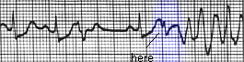

VENTRICULAR TACHYCARDIA

Definition
- Repetitive firing of an irritated ventricular ectopic focus (cell)
- 3 (Janie) or 4 (book) PVC’s in a row constitute V-tach
- Can be intermittent
- SA node discharges independently (atria depolarize, not the ventricles- AV dissociation)
- P waves are seldom seen in sustained V-tach
- Is an emergency (Pt may or may not have a pulse)

Causes
- AMI
- CAD
- K imbalance
- Long QT interval
- Cardiac surgery
- Digoxin imbalance

Characteristics

Ventricular & Atrial Rate: Ventricular rate is 100 to 200 bpm, atrial rate depends on the underlying rhythm
Ventricular & Atrial Rhythm: Usually regular, atrial rhythm may also be regular
QRS Shape & Duration: Usually normal. Duration is 0.12 or more: bizarre, abnormal shape
P Wave: Very difficult to detect, may not see it
PR Interval: Very irregular, if P waves are even seen
P:QRS Ratio: If P waves are seen, usually more QRS complexes than P waves

Symptoms
- Depends on ventricular rate
- Slower rates are better tolerated

Treatment
- Treat the cause
- Oxygen
- EKG
- Amiodarone
- Cardioversion
- If pulseless, defibrillation

Ventricular Tachycardia

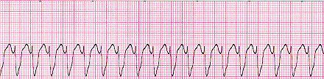

Ventricular Fibrillation

Definition
- Chaotic electrical activity
- No discernable P-QRS-T complexes
- Cardiac arrest
- Rapidly fatal

Causes
- AMI
- Hypokalemia
- Hypomagnesaemia

Characteristics

Ventricular Rate: Greater than 300 per minute
Ventricular Rhythm: Extremely Irregular, without a specific pattern
QRS Shape & Duration: Usually normal. Irregular waves without recognizable QRS complexes
P Wave: Absent
PR Interval: Absent
P:QRS Ratio: Absent

Symptoms
- Loss of consciousness
- Absence of a pulse
- Seizures
- Development of respiratory & metabolic acidosis

Treatment
- CPR
- ACLS
- Defibrillation
- Amiodarone, lidocaine, magnesium sulfate for hypomagnesaemia or torsades de pointes

Ventricular Fibrillation (Fine)

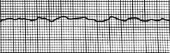

Ventricular Fibrillation (Course)

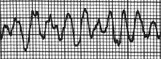

Asystole

Definition
- Ventricular standstill
- Complete absence of any ventricular rhythm
- No electrical impulse
- No cardiac output or vital signs

Treatment
- CPR
- ACLS
- Make sure that the patient is not in fine v-fib

Asystole

