Disorders of the Thyroid and Parathyroid Glands
Slide Addendum
(Mrs. Shepherd’s Lecture yesterday)

Thyroid
- Cellular Metabolism
- Growth
- Activity
- Influences many organs

Hyperparathyroidism
- Overactivity of the parathyroid gland & excessive secretion of PTH
- Promotes bone reabsorption of calcium (increases risk of calcium kidney stones)

Causes
- Rickets, Vit D deficiency, renal failure, laxative abuse, adenoma

S/S
- Loss of memory, depression, PSYCHOSIS, N/V, constipation, recurring kidney stones, low back pain, knee and joint pain, vision impairment from cataracts, increased risk of PUK, anorexia, aching, fatigue, demineralization of the bones (seen on x-ray) that puts the patient at risk for fractures, benign “giant cell” bone tumors from overgrowth of osteoclasts, dysrhythmias

Diagnosis
- Persistent elevated serum calcium (this alone is not enough for diagnosis)
- Elevated concentration of parathormone
- Bone changes on x-ray
- Ultrasound, MRI, thallium scan, and biopsy may be done to evaluate parathyroid function, localize parathyroid cysts, adenomas, or hyperplasia

Treatment

Surgery
- Surgical removal of the parathyroid tissue
- In patients without symptoms or with mild symptoms, only mildly elevated serum calcium, and normal renal function, surgery may be delayed and the patient will be monitored closely for climbing serum calcium, bone deterioration, renal impairment, or the development of kidney stones

Hydration
- Encourage daily intake of at least 2000cc/day to reduce the risk of stones
- Encourage cranberry juice (lowers pH)
- Teach the patient to recognize and report S/S of kidney stones including:
  - Abdominal pains
  - Hematuria

- Avoid thiazide diuretics (decrease renal excretion of calcium)
- Avoid dehydration (increases risk of calcium crisis)
- Seek immediate care for illnesses that may cause dehydration and further increase calcium levels (N/V/D)

Mobility
- Walking
- Rock in a rocking chair
- Encourage ambulation because bones subjected to more exercise give up less calcium
- Bedrest increases calcium secretion from the bones (increases risk of stones, too!)

Diet and Medications
- Short term oral phosphates
- If the patient has PUD, give antacids and protein
- Improve appetite secondary to anorexia caused by hypercalcemia
- Offer prune juice, increased fluid intake, stool softeners, and ambulation to reduce constipation

Nursing Management
- Monitor EKG for dysrhythmias
- Record I & O
- Monitor labs (Ca, K, Na, Phosphate, Mg)
- Strain urine to check for stones
- Monitor breath sounds for pulmonary edema
- Keep the patient from falling to prevent pathological fractures (remember, poor bone health)
- Teach the patient about regular monitoring of labs
- Patients may be depressed because symptoms are vague, and it may take a while to get this diagnosed
- The family may think this disease is all in the patient’s head
- Educate the patient and family about the course of the disease
- Be understanding and supportive
- Dehydration, immobility, and diet are very important in the surgical patient
- Monitor patient for tetany after parathyroidectomy
- Remember that calcium will DROP after parathyroidectomy
- Patients with healthy bones will begin to regulate calcium quicker than those with significant bone disease
- Calcium supplements have to be taken throughout the day instead of all at once, because the body only absorbs so much calcium at a time

Hypoparathyroidism
- Uncommon, but does occur
- Decreased PTH secretion
- Poorly performing parathyroid

Causes
- Damaged parathyroid gland secondary to thyroid surgery
- Hypocalcemia
- Hyperphosphatemia
- Hypomagnesemia
- Congenital
- Tumors

S/S
- Neuromuscular irritability
- Tetany
- Muscle spasms
- Hyperflexia,
- Altered sensorium
- Psychosis
- Positive Chvosteks and Trosseau’s signs
Trosseau’s Sign
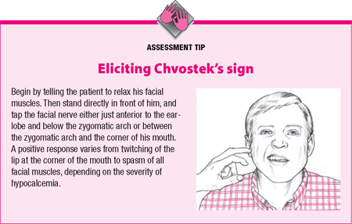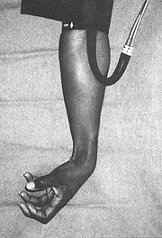

- Muscle twitching (early sign of tetany)

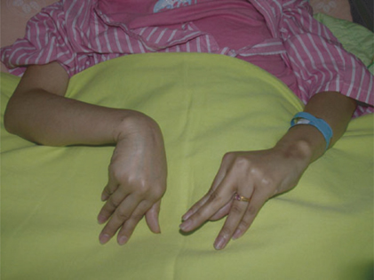
- Monitor EKG (Prolonged QT and QRS, heart block, and decreased cardiac output)

Interventions
- Maintain airway
- Institute seizure precautions (may start Phenobarbital or Dilantin)
- Because of the neuro irritability and risk for seizures, the environment must be kept quiet, dim, free of drafts, and sudden movements
- Keep trach tray at the bedside
- Check for Chvostek’s and Trousseau’s signs
- Monitor EKG
- When hypocalcemia and tetany occur after thyroidectomy, the immediate treatment is IV calcium gluconate
- If patient takes digoxin, watch for dysrhythmias
- Could lead to digoxin toxicity (N/V/Anorexia, halos around lights)
- Administer parathormone (only used sparingly because of the high incidence of allergy)
- Increase Ca levels to 9-10 mg/dL
- Treat anxiety with Ativan
- Monitor renal function

Patient Education
- High calcium, low phosphorus diet
- Remember that eggs, milk, and milk products are great sources of calcium, but are restricted because of high phosphate content
- Spinach, another good source of calcium, is restricted due to oxalate content (think stones!)
- Frequent follow-up for serum calcium levels
- Recognize symptoms of hypercalcemia if on medications
- Keep medications away from light
- Aluminum may be administered after meals to bind phosphates
- Vitamin D supplements are usually required and enhance calcium absorption from the GI tract

Nursing Management
- Remember that a lot of these patients have this problem because of recent thyroidectomy, so they will still require post-surgical care for the thyroidectomy
- Monitor frequently for signs of hypocalcemia and anticipate tetany, seizures, and respiratory difficulty
- Keep calcium gluconate at the bedside!
- If the patient has a cardiac problem or is on digoxin, push calcium gluconate slowly!
- Calcium and digoxin potentiate each other and increase systolic contraction which can produce FATAL dysrhythmias
- Cardiac patients require continuous telemetry and frequent assessment
Hyperthyroidism
- Too much TSH (regulated by the pituitary)
- Also known as Grave’s disease, goiter, or thyroidtoxicosis
- 2nd most prevalent endocrine disorder (DM is #1)
- Everything speeds up!

Causes
- Genetics
- Autoimmune
- Tumor
- Too much synthroid
- Antibody response to stress & infection

S/S
- Overactive!
- Short attention span
- Diarrhea (2° to increased peristalsis)
- Intolerance to heat
- Ravenous appetite with weight loss
- Exophthalmos

(top two pics are before treatment, bottom two are after treatment)
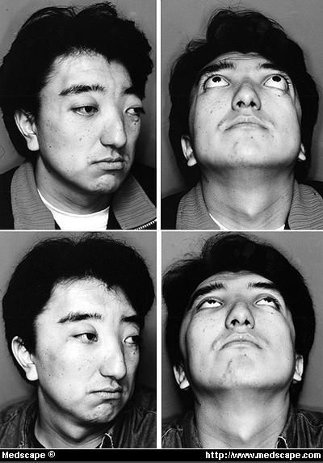

- Enlarged thyroid
- Tachycardia
- Hypertension
- Increased temperature
- Irritability
- Amenorrhea
- Goiter (not always big, but can grow large and compress the airway)

Small Goiter
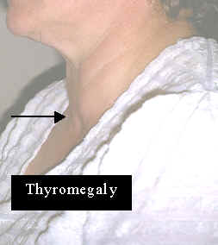

Big Goiter
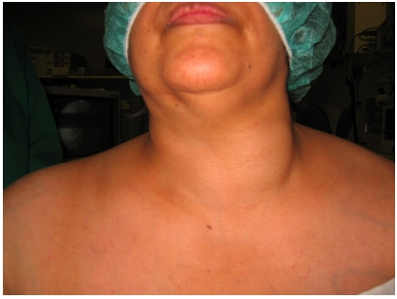

REALLY Big Goiter
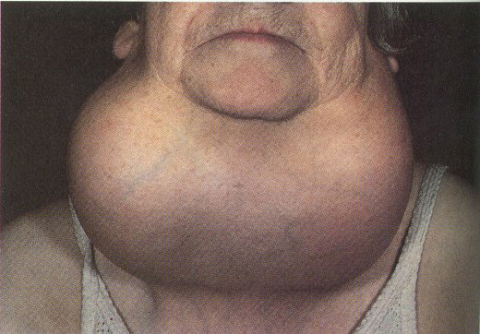

- Some patients may not have any symptoms
- Often is misdiagnosed and goes untreated

Treatment
- Surgical removal of the thyroid
- Beta-blockers
- Sedation
- PTU-drug therapy (Block synthesis of T3 and T4)
- Radiation
- Adenectomy of a portion of the anterior pituitary gland where a TSH-producing tumor is located
- Thyroidectomy, Adenectomy, radiation, and PTU drug therapy will all make the client have hypothyroidism requiring hormone replacement

Nursing Diagnosis
- Decreased cardiac output
- Deficient knowledge
- Imbalanced nutrition (less than body requirements)
- Risk for injury
- Ineffective coping

Nursing Interventions
- Provide a calm, restful atmosphere
- Observe for S/S of thyroid storm
- High calorie, high protein diet
- 6 small meals per day
- Avoid food that irritate the GI tract and can cause diarrhea
- Keep noise and light to a minimum
- Administer anxiety meds
- Perform eye care for exophthalmos:
  - Artificial tears
  - Protect from eye injury
  - Sunglasses in bright light
  - Annual eye exams

Education
- Client should wear a medic alert bracelet
- After definitive treatment, resulting hypothyroidism will require daily hormone replacement
- Dietary needs: high calorie, high protein, low-caffeine, low-fiber (if the patient has diarrhea)
- Take medications exactly as prescribed

Thyroid Storm
- Medical emergency

S/S
- TEMP > 101.3° up to 106°
- Delirium
- Coma
- Tachycardia > 130
- Vomiting
- Confusion
- Wide pulse pressure
- Systolic murmur (sternal border)
- Difficulty concentrating or answering questions
- Weakness & fatigue
- Dyspnea, especially on exertion
- Flushed, paper-thin skin
- Exopthalmos

Diagnosis/Interventions
- Goal is to maintain circulatory and renal function
- Do TSH, T3, T4
- Scan Thyroid (done with dye-ask about allergies)
- May do biopsy
- Start humidified O2
- Obtain arterial blood gasses
- Pulse Ox
- Maintain airway
- Bring down temp (cooling blankets & Tylenol suppository)
- No ASA or ASA products (interferes with thyroid function)
- Protect eyes (moisten with saline)
- NPO
- IV
- Record I & O
- Foley
- Telemetry
- Determine what precipitated storm... Infection? Stress? Thyroidectomy? (While removing the thyroid during surgery, multiple hormones may be excreted)

Hypothyroidism
- Decreased production of thyroid hormone
- More common in women and elderly
- Everything slows down!

Causes
- Thyroidectomy
- Radiation
- Chronic thyroiditis (autoimmune-Hashimoto’s disease)
- Pituitary failure to produce TSH

S/S
- Extreme fatigue
- Intolerance to cold
- Constipation
- Weight gain despite decreased intake (slow basal metabolic rate)
- Dry hair
- Hair loss
- Dry, brittle nails and skin
- Decreased LOC
- Apathy
- Increased triglycerides and lipids
- Vague symptoms that may not be diagnosed for quiet some time

Treatment
- Thyroid hormone replacement for life! (Synthroid)
- High bulk, low calorie diet
- Encourage activity with periods of rest
- Monitor labs
- Give stool softeners, if needed
- Give medication as ordered (observe for s/s of hyperthyroidism

Nursing Diagnosis
- Deficient knowledge
- Noncompliance
- Activity intolerance

Interventions and Teaching
- Medication regimen teaching (everyday, same time, 30 minutes before eating!)
- Takes weeks to work
- Educate the patient about the S/S of myxedema
  - Hypotension
  - Hypothermia
  - Hyponatremia
  - Hypoglycemia
  - Respiratory failure

- If myxedema occurs:
  - Maintain airway
  - Support BP and P rate with IV synthroid plus IV hydrocortisone
  - Give O2
  - Pulse Ox
  - Monitor I & O
  - Give fluids
  - Monitor VS
  - If infection is present, give antibiotics
  - Make sure the patient understands that they need the supplements for life!

- Prevent constipation with:
  - Fluid intake of 3L/day
  - High-fiber diet, including fresh fruit and vegetables
  - Increased activity
  - Little or no use of enemas and laxatives
  - Encourage use of stool softeners
- Avoid sedation
- Medic-Alert bracelet

