Chest Tubes
(AKA Chest Drainage System)
Purpose
- To remove air or fluid from the pleural space
- Commonly inserted to resolve a pneumothorax, hemothorax, pleural effusion, or to drain blood from the mediastinum after thoracic surgery

Background

Pneumothorax
- Most common reason for inserting a chest tube
- Also known as a “collapsed lung”
- Caused by external air entering the pleural space from a hole in the chest wall or by air in the lungs entering through a hole in the pleura
- The collected air disrupts the normal negative pressure within the lungs (the vacuum that keeps the lungs expanded)
- Loss of this vacuum causes the lung to collapse
- A collapse greater than 15% can lead to respiratory compromise, so insertion of a chest tube is necessary

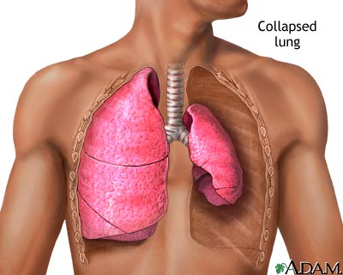

Tension Pneumothorax
- Life-threatening emergency
- Occurs when the air in the pleural space increases to a dangerous level
- The increasing pressure causes a shift that pushes the heart, great vessels, trachea, and lungs to the unaffected side
- This shift severely decreases lung expansion, venous return, and cardiac output
- S/S include severe respiratory distress, tracheal deviation to the unaffected side, cyanosis, muffled heart sounds, and possibly cardiac arrest
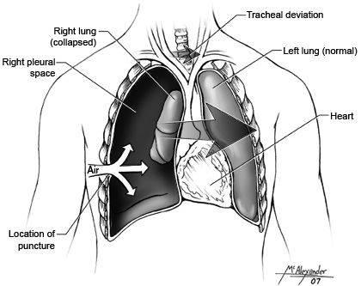

Hemothorax
- Collection of blood in the pleural space
- Can be life-threatening
- Can be a combination of air and blood or a hemopneumothorax
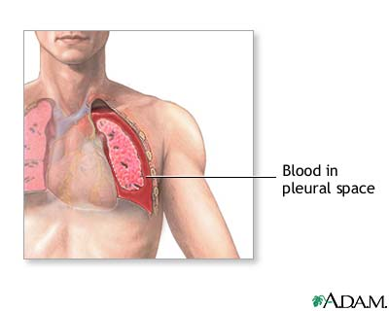
Risks for Pneumothorax

- Trauma
- COPD
- Smoking
- Bronchoscopy
- CPR
- Central line insertion
- Mechanical ventilation

Chest Tubes
- Sterile, flexible, non-thrombogenic catheter made of vinyl or silicone
- Measure about 20” long and varies in diameter
- The proximal end, which rests in the pleural space, has several eyelets to drain air and fluid and to prevent occlusion
- The distal end connects to the chest drainage unit (CDU)
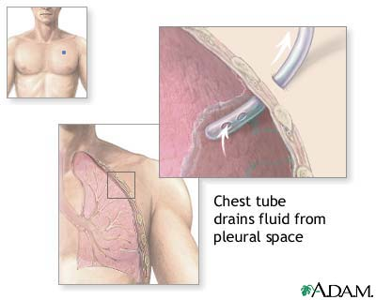

Chest Drainage Units (CDU)
- Multiple brands
- 3 main components
  - Collection chamber
  - Water-seal chamber
  - Suction-control chamber or regulator
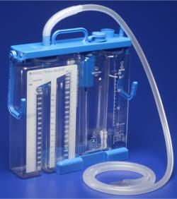

- 2 Types
  - Water Seal System
  - Dry Suction Water Seal System

Water Seal System
- Collection chamber
-acts as a reservoir for fluid draining from the chest tube
-graduated for easy measuring of drainage
-suction may be added to create negative pressure and promote drainage of fluid and removal of air
- Suction Control Chamber
-regulates the amount of negative pressure applied to the chest
-the amount of suction is determined by the water chamber
-after the suction is turned on, bubbling appears in the suction chamber
-adding more fluid, results in more suction
- Positive Pressure Valve
-located at the top of the suction chamber
-automatically opens with increases in positive pressure within the system
-air is automatically released through the positive pressure release valve if the suction tubing is inadvertently clamped or kinked
- Water Seal Chamber
-has a one-way valve or water seal that prevents air from moving back into the chest when the patient inhales
-there is an increase in the water level with inhalation and a return to the baseline level during exhalation (referred to as “tidaling”)
-intermittent bubbling in the water chamber is normal, but continuous bubbling can indicate an air leak (I’ve seen this in 3 NCLEX books)
-bubbling and tidaling do not occur when the tube is placed in the mediastinal space; however fluid may pulsate with the heart beat
-the water level in the water seal chamber reflects the negative pressure present in the intrathoracic cavity
-a rise in the water level reflects the negative pressure in the pleural or mediastinal space
-too much negative pressure can cause trauma to tissue
-most CDU’s have an automatic means to prevent excessive negative pressure

**If the chest tube is connected to gravity drainage only, suction is not used. The pressure is equal to the water seal only. Two-chamber CDU’s are available for use with patients who need only gravity drainage**

Dry Suction Water Seal System
- Water Seal Chamber
-filled with water to the 2-cm level
-bubbling in this area can indicate an air leak
- Dry Suction Control Chamber
-contains a regulator dial that conveniently regulates vacuum to the chest drain
-water is not required for suction in these systems
-without the bubbling water, these machines are quieter
-if the container is knocked over, the water seal may be lost
-when the tube is connected to the suction source, the regulator dial allows the desired level of suction to be dialed in
-the suction is increased until an indicator appears
-the indicator has the same functioning as the bubbling in the traditional water seal system

