Cardiac Assessment

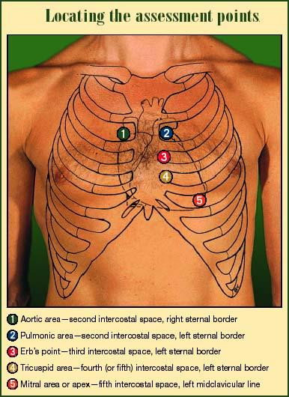

S1
- Beginning of systole
- Known as ventricular gallop
- Mitral and Tricuspid valve close
- Ventricles contract
- It’s the 1st sound heard (lub)
- Listen with the diaphragm of the stethoscope
- Best heard over the apical area (left, mid-clavicular, 5th intercostal space)

S2
- Beginning of diastole
- Known as atrial gallop
- Pulmonic and aortic valve close
- It’s the 2nd sound heard (dub)
- Listen with the diaphragm of the stethoscope
- Best heard over the base area (“A” and “P” areas, 2nd intercostal space)

S3
- Heard right after S2 (early diastole)
- Normal in kids and young adults
- Abnormal in older adults (consider heart failure)
- Sounds like “lub-de-dub” or “Kentucky”
- Listen with the bell of the stethoscope
- <Listen here> http://www.uni-duesseldorf.de/WWW/MedFak/Herz-Kreislauf-Physiologie/lehre/sounds/html/3rd_heart_sound.html

S4
- Heard just before S1 (late diastole)
- Abnormal (consider MI or hypertension)
- Sounds like “de lub-dub” or “Tennessee”
- Listen with the bell of the stethoscope
- <Listen here> http://www.uni-duesseldorf.de/WWW/MedFak/Herz-Kreislauf-Physiologie/lehre/sounds/html/4th_heart_sound.html

Murmurs
- Turbulent blood flow through the heart
- Usually comes from narrowing or leaking of the heart valves
- May sound like whooshing sound
- Graded from 1-6
- Grades 1 and 2 are soft and difficult to hear without experience
- We should be able to hear at least grade 3 and above
- For a grade 4 and above, you should be able to feel vibration on the chest or what is known as “thrill”.
- Thrill may feel like a cat purring
- <Listen here> **scroll down to heart sounds** http://www.bioscience.org/atlases/heart/index.htm

Pericardial Friction Rub
- Sound heard in response to inflammation of the pericardial sac
- Heard during systole and diastole
- Best heard with diaphragm with client sitting up and leaning forward
- easy to confuse with a pleural friction rub so ask the patient to hold their breath, if you still hear it than it’s a pericardial friction rub because the inflamed pericardial layers continue rubbing with each heartbeat-a pleural rub stops when breathing stops
- <Listen here> http://filer.case.edu/~dck3/heart/sounds/prubbing.wav

Other listening material

http://filer.case.edu/dck3/heart/listen.html

