Brain Structure | Function | Associated Signs and Symptoms
Cerebral Cortex  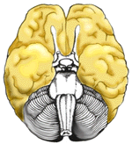  Ventral View ( From bottom) | The outermost layer of the cerebral hemisphere which is composed of gray matter. Cortices are asymmetrical. Both hemispheres are able to analyze sensory data, perform memory functions, learn new information, form thoughts and make decisions.
Left Hemisphere | Sequential Analysis: systematic, logical interpretation of information. Interpretation and production of symbolic information:language, mathematics, abstraction and reasoning. Memory stored in a language format.
Right Hemisphere | Holistic Functioning: processing multi-sensory input simultaneously to provide "holistic" picture of one's environment. Visual spatial skills. Holistic functions such as dancing and gymnastics are coordinated by the right hemisphere. Memory is stored in auditory, visual and spatial modalities.
Corpus Callosum  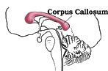 | Connects right and left hemisphere to allow for communication between the hemispheres. Forms roof of the lateral and third ventricles. | - Damage to the Corpus Callosum may result in "Split Brain" syndrome.
Frontal Lobe  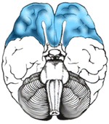  Ventral View (From Bottom)  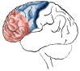  Side View | Cognition and memory.  Prefrontal area: The ability to concentrate and attend, elaboration of thought. The "Gatekeeper"; (judgment, inhibition). Personality and emotional traits.  Movement:  Motor Cortex (Brodman's): voluntary motor activity.  Premotor Cortex: storage of motor patterns and voluntary activities.  Language: motor speech  Diagram | - Impairment of recent memory, inattentiveness, inability to concentrate, behavior disorders, difficulty in learning new information. Lack of inhibition (inappropriate social and/or sexual behavior). Emotional lability. "Flat" affect.  - Contralateral plegia, paresis.  - Expressive/motor aphasia.
Parietal Lobe  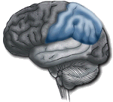 | Processing of sensory input, sensory discrimination.  Body orientation.  Primary/ secondary somatic area. | - Inability to discriminate between sensory stimuli.  - Inability to locate and recognize parts of the body (Neglect).  - Severe Injury: Inability to recognize self.  - Disorientation of environment space.  - Inability to write.
Occipital Lobe  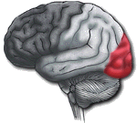 | Primary visual reception area.  Primary visual association area: Allows for visual interpretation. | - Primary Visual Cortex: loss of vision opposite field.  - Visual Association Cortex: loss of ability to recognize object seen in opposite field of vision, "flash of light", "stars".
Temporal Lobe  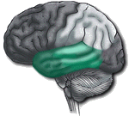 | Auditory receptive area and association areas.  Expressed behavior.  Language: Receptive speech.  Memory: Information retrieval. | - Hearing deficits.  - Agitation, irritability, childish behavior.  - Receptive/ sensory aphasia.
Limbic System  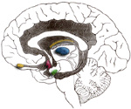 | Olfactory pathways:  Amygdala and their different pathways.  Hippocampi and their different pathways.  Limbic lobes: Sex, rage, fear; emotions. Integration of recent memory, biological rhythms.  Hypothalamus. | - Loss of sense of smell.  - Agitation, loss of control of emotion. Loss of recent memory.
Basal Ganglia  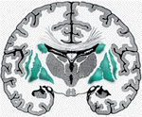 | Subcortical gray matter nuclei. Processing link between thalamus and motor cortex. Initiation and direction of voluntary movement. Balance (inhibitory), Postural reflexes.  Part of extrapyramidal system: regulation of automatic movement. | - Movement disorders: chorea, tremors at rest and with initiation of movement, abnormal increase in muscle tone, difficulty initiating movement.  - Parkinson's.

