Basic Renal Anatomy

Kidneys
- Two, bean-shaped organs
- Located behind and outside the peritoneum
- Protected by the ribs and the back and abdominal muscles
- An adrenal gland lies on top of each kidney
- Divided into (2) sections
  - Medulla
    - Inner portion
    - Contains the loop of Henle and the collection ducts
  - Cortex
- Outer portion
- Contains the nephrons (basic unit of the kidney)

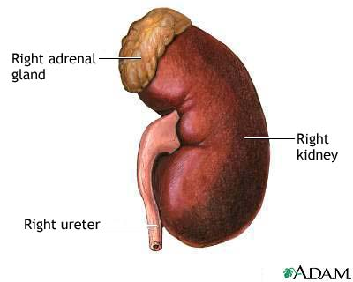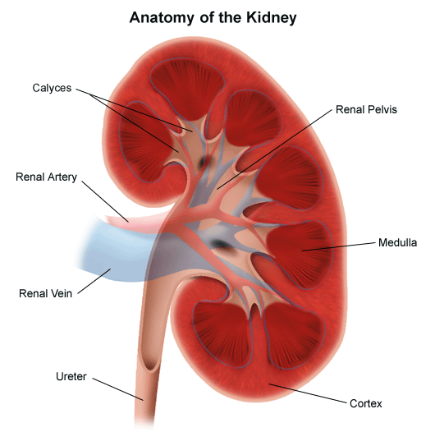

Blood Supply
- The kidney receives about 25% of the total cardiac output
- The renal artery brings oxygen and nutrients to the kidney
- Kidney is heavily vascular (lots of potential for bleeding!)

Nephron
- Basic working unit of the kidney
- We have about 1 million in each kidney
- Basic components
  - Filter (glomerulus)
- Similar to a plasma membrane
- Filters fluid and small molecules
- Usually does not allow blood or albumin to pass (too large)

  - Tube (tubule)
- Just a long tube with 3 sections
  - Proximal tubule
  - Loop of Henle
  - Distal tubule

- The distal tube feeds into the collection duct which takes waste filtered from the glomerulus and sends it to the renal pelvis which then will feed into the ureter to travel to the bladder

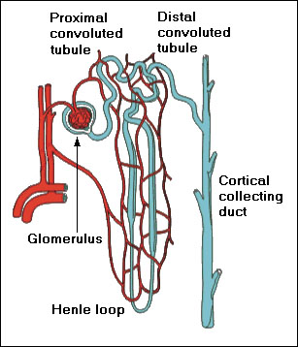

Ureters
- Hollow, muscular tubes
- Originate in the renal pelvis
- End in the bladder
- Moves urine by peristalsis

Bladder
- Muscular, hollow sac
- Located behind the pubic bone
- The adult bladder hold 300-500 mL of urine
- Basically, the bladder is a storage device

Urethra
- Begins at the base of the bladder
- Ends at the urinary meatus

