Burns

Tissue injury or necrosis caused by transfer of energy from a heat source to the body

Types of Burns
- Thermal
- Radiation
- Electrical
- Chemical

Tissue Destruction results from:
- Coagulation
- Protein denaturation
- Ionization of cellular contents

Critical systems affected:
- Respiratory
- Integumentary
- Cardiovascular
- Renal
- Gastrointestinal
- Neurologic

Severity

 | 1st Degree | 2nd Degree | 3rd Degree
Thickness | Superficial partial-thickness (sunburn) | Deep partial-thickness destruction of the epidermis and upper layers of the dermis | Full-thickness injury and total destruction of the epidermis and dermis
Pain | Painful (relieved by cooling) | Painful  (sensitive to touch and cold air) | Painless
Appearance | Pink or red | Red or white, weeps fluid, blisters present | Appears dry and leathery, black
Edema | Slight | Very edematous | Yes
Other Info |  | Hair follicles are intact, blanching followed by cap refill, heals without surgical intervention, usually does not scar | Skin cannot regenerate, skin grafts required, underlying tissue (fat, fascia, tendon, and bone) may be involved

1st Degree Burn

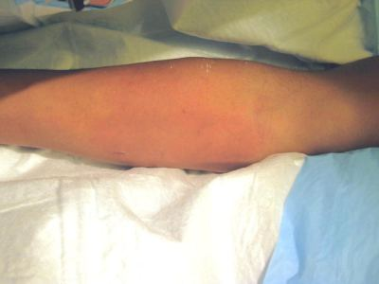

2nd Degree Burn
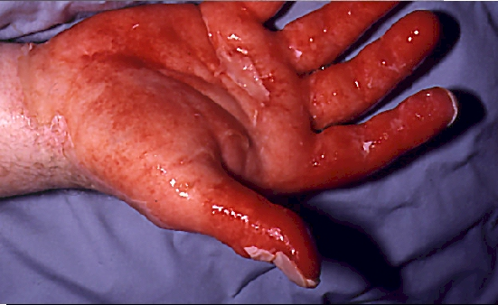

3rd Degree Burn
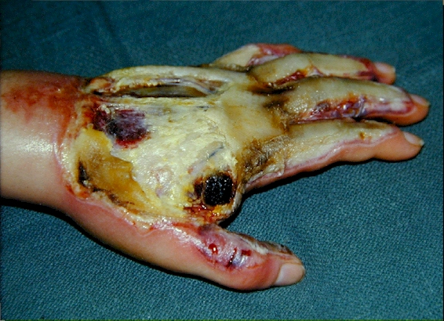

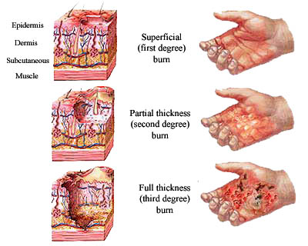

Severity
- Determined by % of body surface area involved
- Rule of nines

Stages of Burn Care
  - Emergent Phase
  - Acute Phase
  - Rehabilitation Phase

Emergent Phase
- Begins at the time of injury
- Fluid shifts from intravascular to interstitial
- Patient is at risk for shock
- Focus is to preserve vital organ function
- Large volumes of fluid administered

Acute Phase
- Beginning of diuresis to near completion of wound closure
- Fluid shift from interstitial to intravascular

Rehabilitation Phase
- Begins with major wound closure to return optimum level of health
- Is usually about 5 years
- Characterized by grafting and rehabilitation specific to the client’s needs

Nursing Assessment
- Always ABC
- Decreased urine output for the first 72 hours
- Increased urine output after the first 72 hours to 2 weeks
- Observe for s/s of dehydration
  - Restlessness
  - Disorientation
  - Decreased urination
  - Poor skin turgor
  - Dry mucous membranes

- Observe for s/s of inhalation injuries
  - Singed nasal hair
  - Circumoral burns
  - Conjunctivitis
  - Sooty or blood sputum
  - Hoarseness
- Listen for crackles, ronchi, and wheezing
- Discuss pre-existing conditions that may influence recovery

Nursing Diagnosis
- Ineffective Airway
- Impaired gas exchange
- Decreased cardiac output
- Deficient fluid volume
- Ineffective tissue perfusion
- Impaired skin integrity
- Pain
- Disturbed body image
- Imbalanced nutrition: less than body requirements
- Risk for infection
- Impaired physical mobility

Nursing Interventions
- Extinguish source of burn
  - Thermal: remove clothing, cool burns with immersion in tepid water, apply sterile dressings
  - Chemical: flush with water or normal saline
  - Electrical: Separate client from electrical source

- Provide an open airway
- Prepare for possible intubation if laryngeal edema is suspected
- Obtain baseline data: VS, blood gases, weight
- Determine depth and extent of burn
- Initiate fluid and electrolyte therapy (LR)
- NG tube may be inserted to prevent vomiting, abdominal distention, and aspiration
- Monitor I & O hourly (at least 30cc/hr)
- Weigh daily
- Provide oral care
- Suction as needed
- Monitor ABGs
- Observe for cyanosis or disorientation
- Administer O2
- Encourage use of incentive spirometer
- Use strict aseptic technique for wound care
- Premediate patient prior to changing dressings
- Monitor body temperature
- Manage pain
- Splint and position patient as ordered to prevent contractures
- Perform ROM exercises (medicate patient prior to)
- Provide adequate nutrition (some patients require up to 5K calories per day)
- Consider nutritional supplements

